[1]

Transmission Lines and Impedance Matching

First A. Author, *Keegan Smith, Francis College of Engineering, University of Massachusetts Lowell*

*Abstract*—This project is about using a read-world application of uses for double stub matching systems. In doing so, we further our understanding of impedance matching with plasma chambers while also using different gases. After creating the double stub system, a RLC or LC circuit was designed to replace the stub matching system.

# INTRODUCTION

T

HESE systems are used for microwave plasma etching, surface preparation for bonding, ashing, surface cleaning, and wire bonding. This system will be able to have input frequencies of 13.7MHz and 13.7GHz due to the impedance matching systems designed for it. There are few inputs to this system. The inputs only include the transmission line for the wave, gas input and RF matching. However, there are many outputs to the chamber, like the vacuum system and many others which are for diagnostic purposes.

Impedances are an important value to consider during the designing of a plasma chamber because you are able to eliminate reflection and thus power loss over a transmission line. This is done by stubs or a matching circuit at some point on the line to match the impedances of the line and the load. One method is to use double stub matching. How this works is, using a Smith Chart, compass, and a pencil, perform series of step plotting values on the chart to match the transmission line and chamber (with the different gases and at the different frequencies separately) impedances. However, with larger differences in impedances, longer stubs are need and this is were and RLC or LC matching circuit are applicable. These systems use large capacitors and inductors to change the impedance of a line to match the load. One advantage is these systems can be built with adjustable components, so range of matching is increased.

1. Equations For Impedance Matching with Smith Chart
2. Equations for LC Impedance Matching Network
3. Units

TABLE I

Units for Magnetic Properties

|  |  |  |  |
| --- | --- | --- | --- |
| Symbol | Quantity | | Unit |
| R | Resistance | | Ω, Ohms |
| *L* | Inductance | | H, Henry |
| *C* | Capacitance | | F, Farads |
| *G* | Resistivity | | S, Siemens |
| *Z* | Impedance | | Ω, Ohms |
| ᵦ | Loss Characteristic | | Rad/S, Radians per Second |
|  | Wavelength | | M, Meters |
|  | Angular frequency | | Rad, Radians |
| *f* | Frequency | | Hz, Hertz |
| X | Reactance | | Ω, Ohms |
|  | |

# Results

The first part of the process was to perform the double stub system. This is done by using the equations listed for this section. The first step was to solve for the impedances for the chamber with gas (equation *A.1)*, and the transmission line that was chosen. Because only resistance and capacitance of the transmission line were given, using equation *A.2* the inductance of the line could be solved for. Secondly, with equation *A.*3 the characteristic impedance of the transmission line could be found. Then, normalization of the impedances was performed using equation *A.4*. Thirdly, using equations *A.5* through *A.7* we are able to find the wavelength of the system at the given frequency “*f* “ (13.7MHz and 13.7GHz). Then, using the values from *A.4*, *A.7* and converting the distance from the load to the first stub, then the distance from the first to second stub, in terms of wavelength (. After that, we are able to use the Smith Chart to find the lengths of the stubs for the impedances to match. Once that was performed for each gas at the two frequencies, simulations of the transmission line were done. The results are seen in the following graphs.

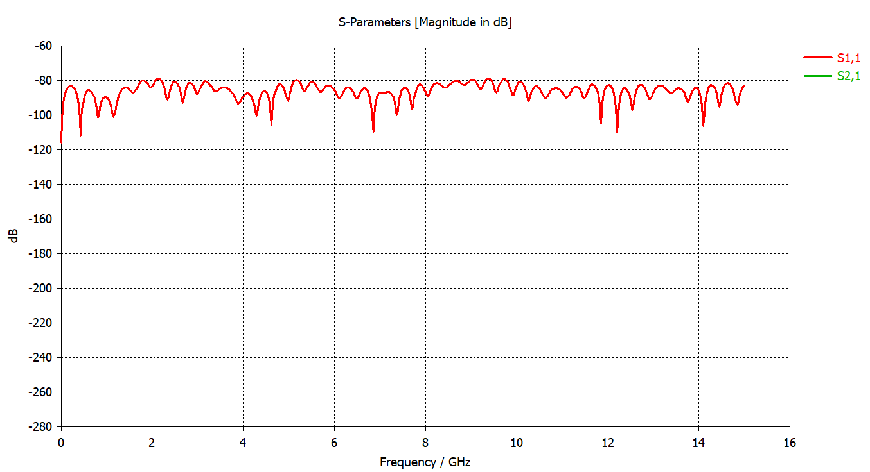

Fig 1. This is the simulation s-parameters of oxygen using the stub lengths found at 13.7MHz

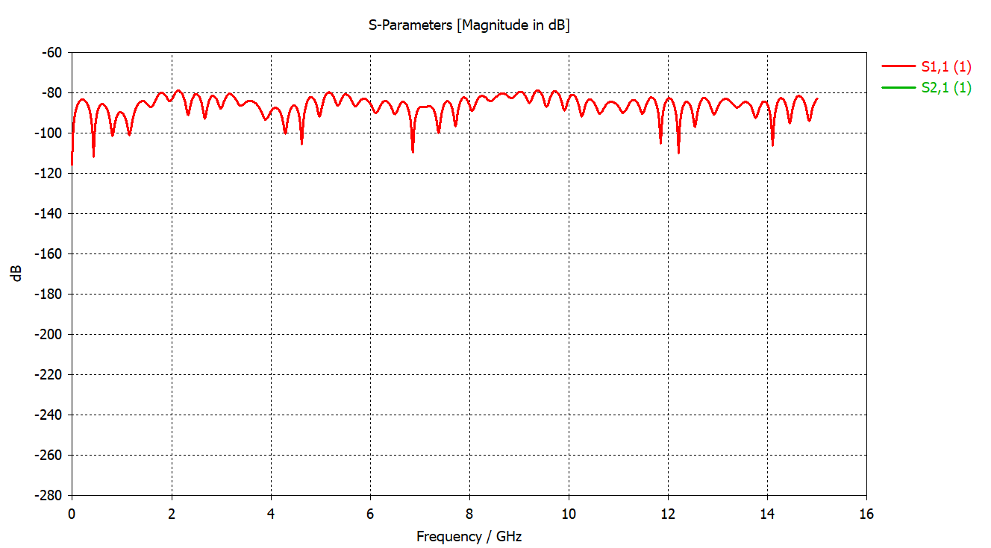

Fig 2. This is the simulation s-parameters of argon using the stub lengths found at 13.7MHz

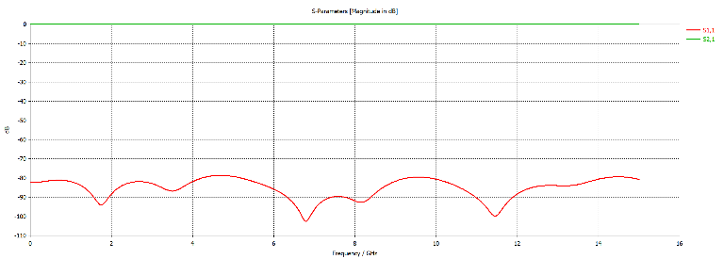

Fig 3. This is the simulation s-parameters of oxygen using the stub lengths found at 13.7GHz

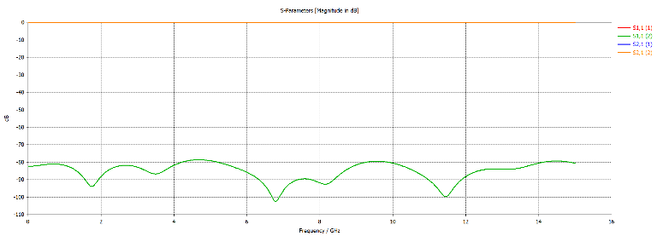

Fig 4. This is the simulation s-parameters of argon using the stub lengths found at 13.7GHz

The first part of the LC circuit design is to solve the equations listed from *B.1-B.5*. Once these calculations are made from *f = 13.7MHz* to *f = 13.7GHz*, the range of capacitances and inductances is found, and a variable capacitor and inductor can be chosen. I found the capacitance to range from 0.598pF to 640.592pF and the inductance to range from 384.5pH to 0.471µH.

# Discussion

The advantage of using this system is the versatility of it. With the calculations being performed at such a large frequency range, and the adjustability of stub tuners and variable inductors and capacitors, one is only a few short equations away from being to operate between the frequencies 13.7MHz and 13.7GHz and not limited to them other than as maxima and minima. This is useful because operating at a set frequency limits the capability of such a costly system. Being able to perform the different tasks such as ashing, bonding and surface cleaning mean you are able to use a singular machine for a few steps in the desired experimentation or manufacturing process. In fact, an improvement of this system could be to automate the impedance matching by using the LC network and an impedance analyzer. Another area of improvement falls on the stub matching system. The results from those simulations proved to be somewhat inconclusive in the functionality of the system.

# Conclusion

In conclusion, this system will be able to operate in the designated frequency range of 13.7MHz to 13.7GHz and perform impedance matches for the required work. The double stub system is the only one that does not seem overly feasible, for the stub lengths do not necessarily make sense because they are very small.

# References

*Data Sheets:*

1. “Flexible Microwave Coax,” Jul. 08, 2013. https://media.digikey.com/pdf/Data%20Sheets/Molex%20PDFs/141SC-1901.pdf

*Applications of Argon and Oxygen Plasmas:*

1. “Oxygen Plasma,” *www.plasmaetch.com*. https://www.plasmaetch.com/oxygen-plasma-treatment.php
2. “Argon Plasma,” *www.plasmaetch.com*. https://www.plasmaetch.com/argon-plasma.php (accessed Nov. 06, 2022).
3. T. Corp, “Plasma Etching | Applications of the Plasma Etching Process,” *www.thierry-corp.com*. https://www.thierry-corp.com/plasma-etching (accessed Nov. 06, 2022).

*Calculation Aids:*

1. “L Network Impedance Matching,” *www.youtube.com*. https://www.youtube.com/watch?v=RrrfZ5nhikM (accessed Nov. 06, 2022).

# Appendix

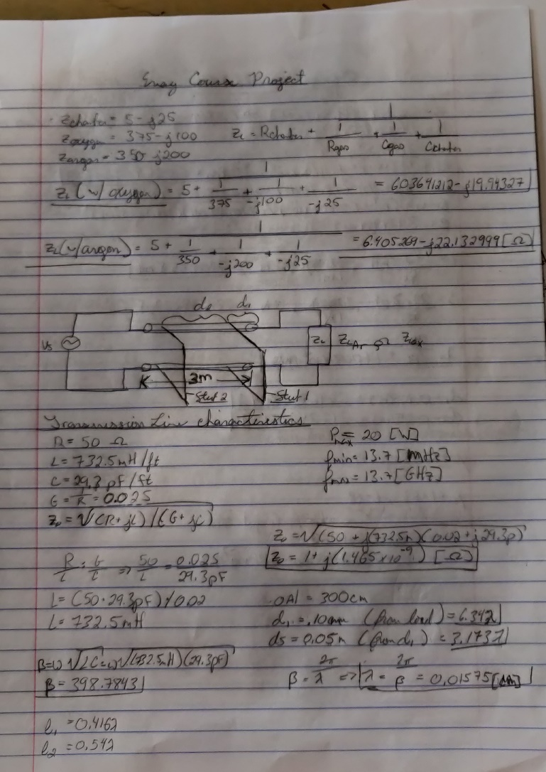Below are the calculations for the stub matching system. See the title of the notes for the frequency, and gas used as well as the datasheet for the coaxial cable used in the calculations.

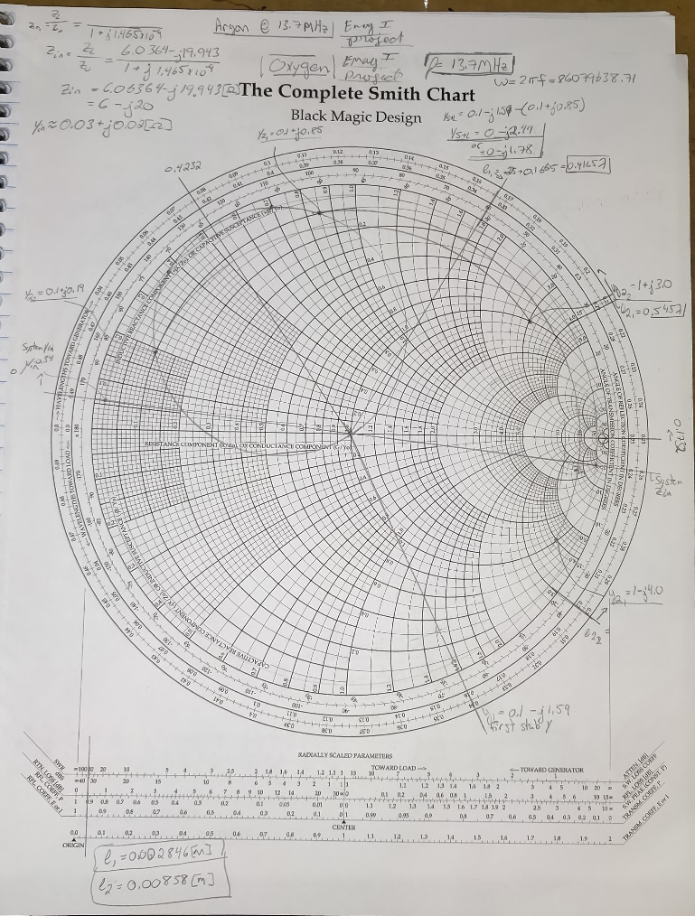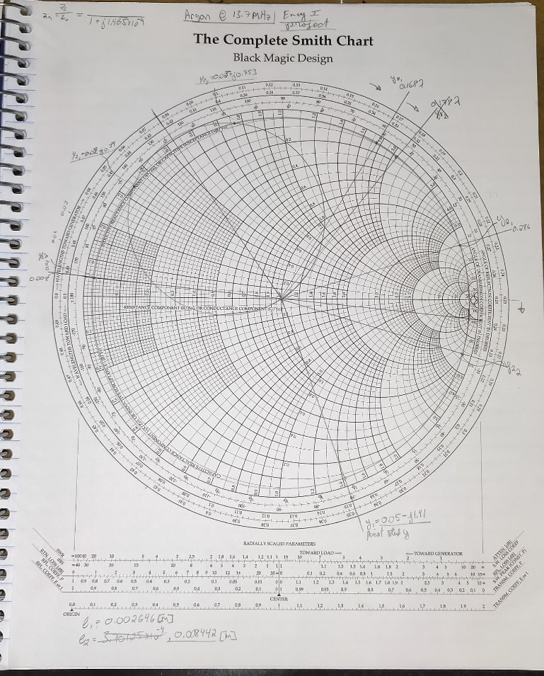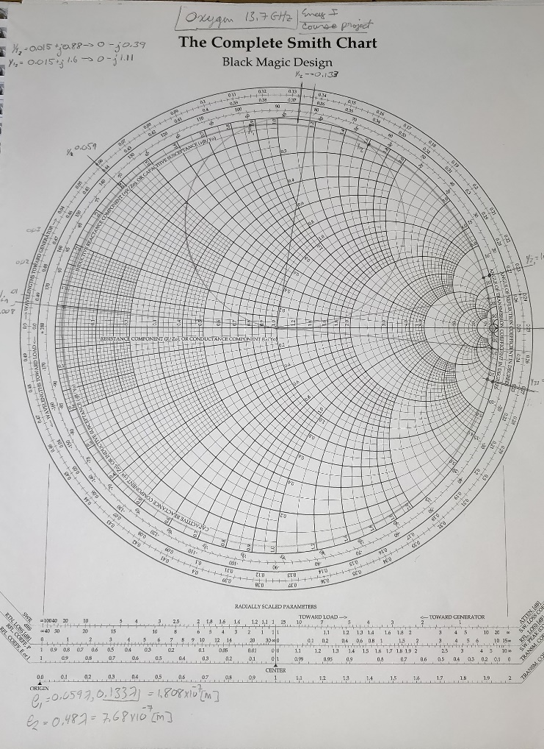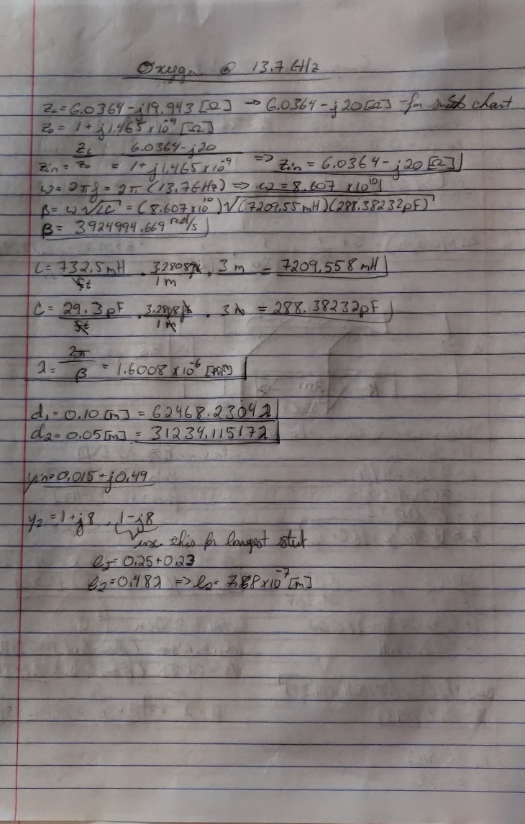

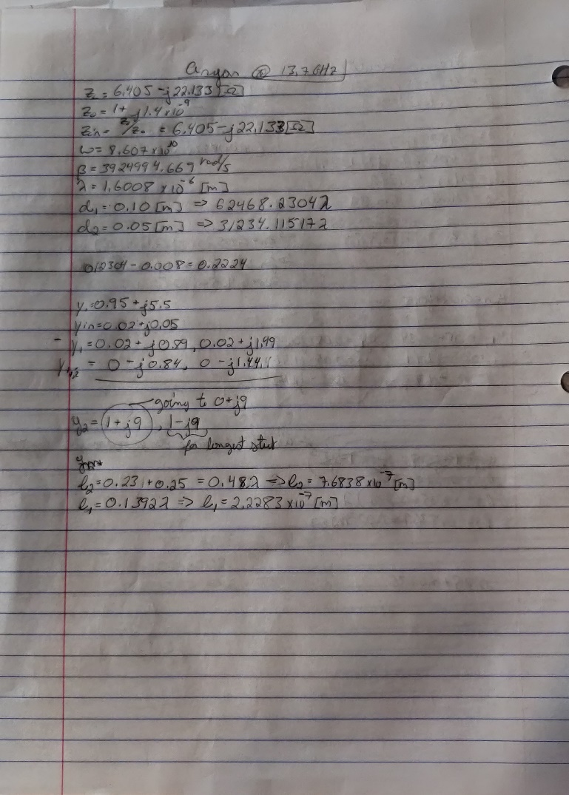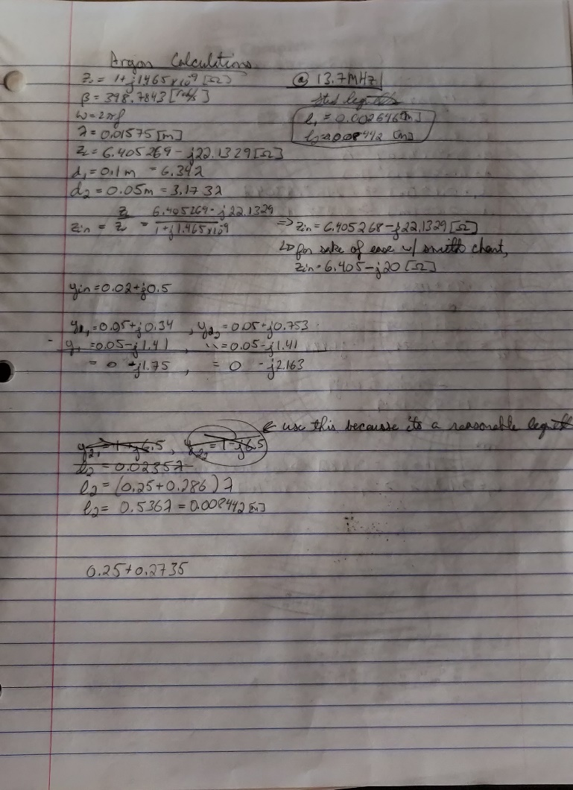

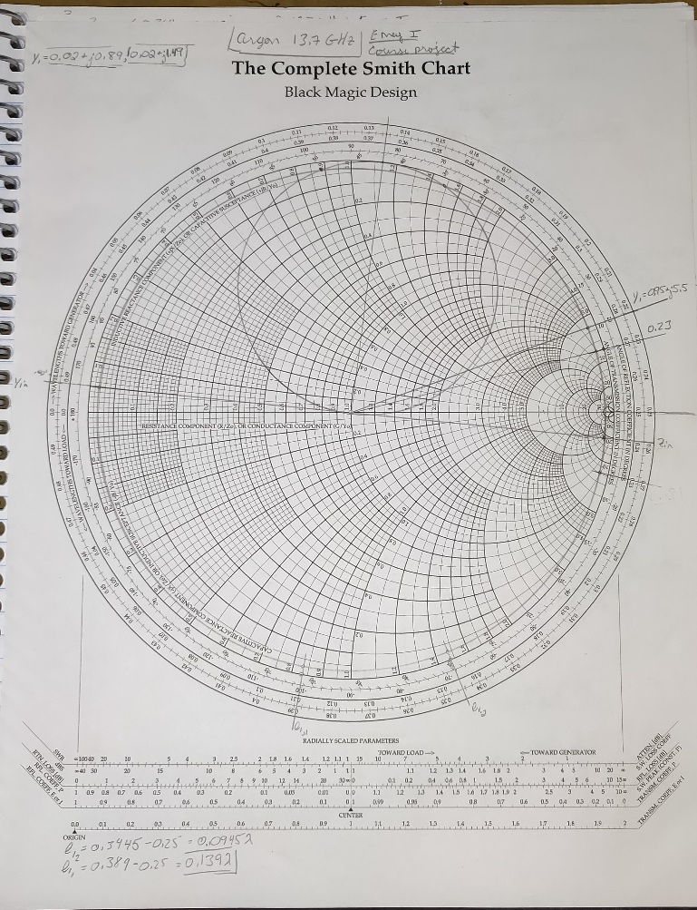

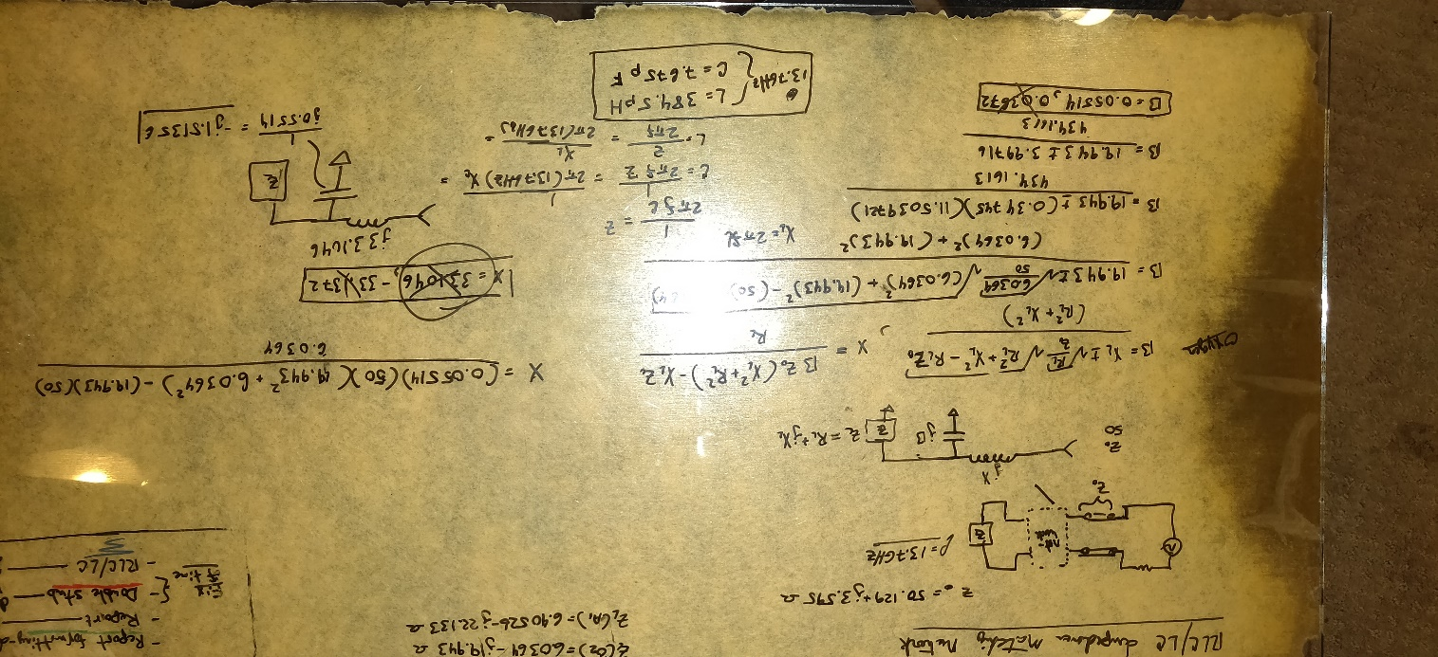LC system calculations.

Coax Cable Datasheet. Also see reference [1].

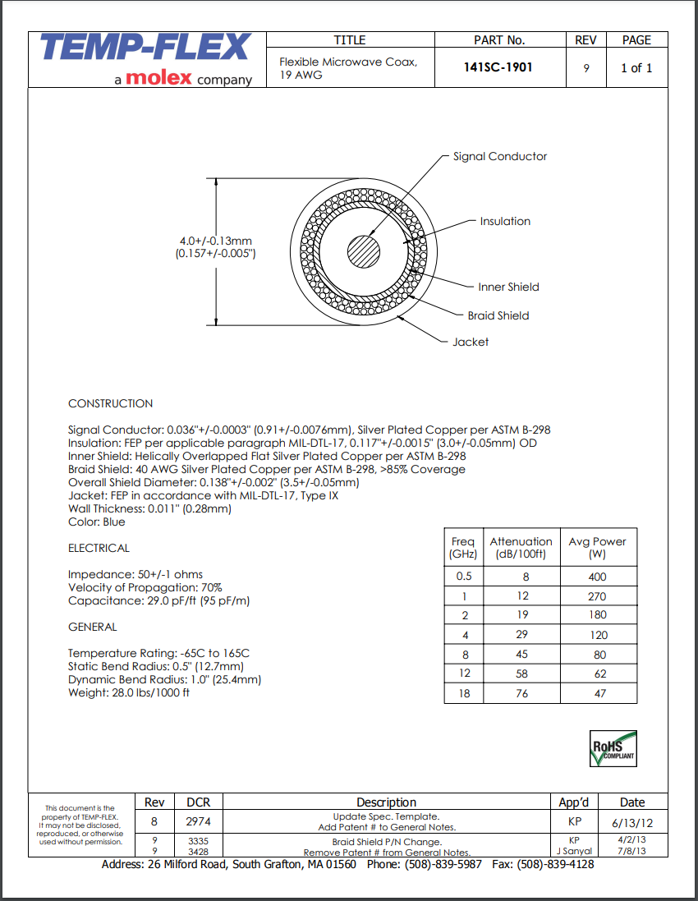

1. 11/06/2022

   Keegan Smith is an Electrical Engineering student at University Massachusetts Lowell and works at Locus Robotics. (e-mail: [Keegan_smith1@student.uml.edu](mailto:Keegan_smith1@student.uml.edu))